# Sieving & filtration

Transport of substances across the fenestra depends on the radius/size of the substances. The process cannot be described with simple diffusion, but more complex pore theory for the transport is necessary.

### Pore Theory

In its simplest form, the pore theory supposes that the capillary walls are pierced with numerous ultramicroscopic openings which are in general too small to allow the passage of plasma protein molecules, but are of sufficient size and number to account for the observed rates of passage of water and nonprotein constituents of the plasma {Pappenheimer1951}.

**Calculation**

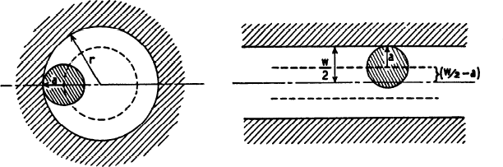{Pappenheimer1951}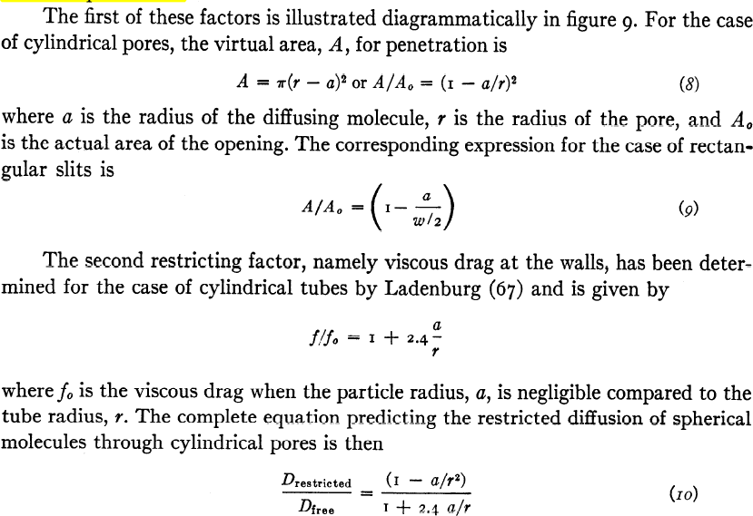

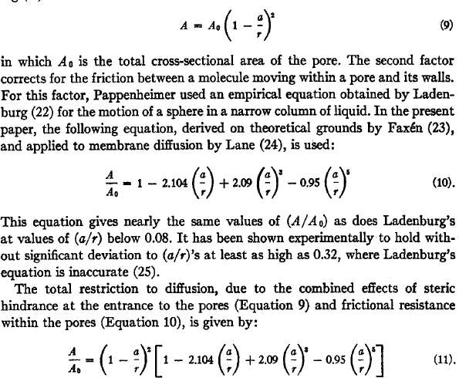

{Renkin1954}

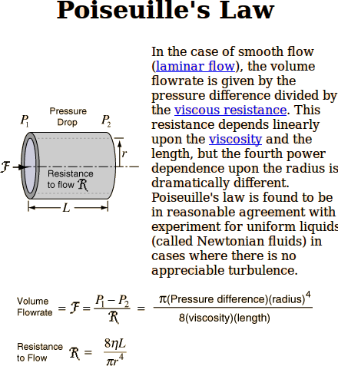

{http://hyperphysics.phy-astr.gsu.edu/hbase/ppois.html}

### Damage of Sieve

High perfusion pressure damages the sieve {Fraser1980}.

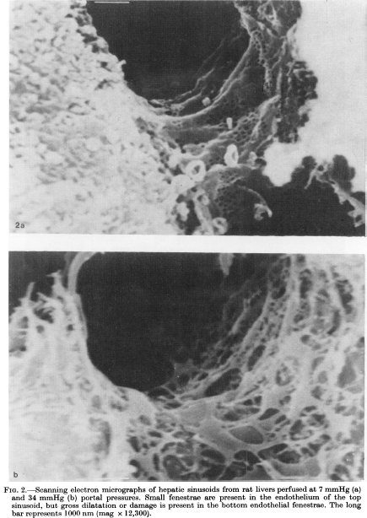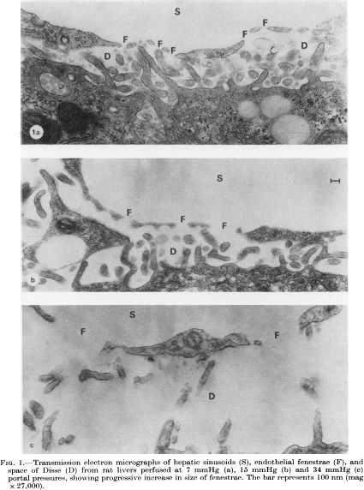

{Fraser1980}

# References

Fraser, R, AG Bosanquet, and WA Day. "Filtration of chylomicrons by the liver may influence cholesterol metabolism and atherosclerosis." *Atherosclerosis* 29.2 (1978): 113-123.

Fraser, R et al. "High perfusion pressure damages the sieving ability of sinusoidal endothelium in rat livers." *British journal of experimental pathology* 61.2 (1980): 222.

Michel, C. (2004). Microvascular permeability, ultrafiltration, and restricted diffusion. *American Journal of Physiology-Heart and Circulatory Physiology*, *287*(5), H1887-H1888.

Pappenheimer, J., Renkin, E., & Borrero, L. (1951). Filtration, diffusion and molecular sieving through peripheral capillary membranes. *Am. J. Physiol*, *167*(13), 2578.

Pappenheimer, J. R. (1953). Passage of molecules through capillary walls. *Physiol. Rev*, *33*(3), 387-423.

Renkin, E. M. (1954). Filtration, diffusion, and molecular sieving through porous cellulose membranes. *The Journal of general physiology*, *38*(2), 225-243.

Rippe, B., & Haraldsson, B. (1994). Transport of macromolecules across microvascular walls: the two-pore theory. *Physiological reviews*, *74*(1), 163-219.

Sarin, H. (2010). Physiologic upper limits of pore size of different blood capillary types and another perspective on the dual pore theory of microvascular permeability. *J Angiogenes Res*, *2*(14), 10.1186.